Tab 1

GAN Assisted Map Reconstruction for First Responders using Sensor Fusion

Christian Jeardoe, Quinn Leboeuf,

Kyle Smejkal, Rufus Tadpatri

**Concept of Operations**

Revision - 3

2 December 2024

Concept of Operations

for

GAN Assisted Map Reconstruction for first responders using Sensor Fusion

TEAM <27>

APPROVED BY:

*Rufus Tadpatri 12/02/2024*

_____________________________

Project Leader Date

_____________________________

Dr. Lusher Date

_____________________________

T/A Date

**CHANGE RECORD**

| **Rev.** | **Date** | **Originator** | **Approvals** | **Descriptions** |
| --- | --- | --- | --- | --- |
| **1** | **09/15/2024** | **GAN Assisted Map Reconstruction** |  | **Draft Release** |
| **2** | **09/26/2024** | **GAN Assisted Map Reconstruction** |  | **Draft Release** |
| **3** | **12/02/2024** | **GAN Assisted Map Reconstruction** |  | **Final Edits** |

**Table of Contents**

**1. Executive Summary 7**

**2. Introduction 7**

2.1 Purpose 7

2.2 Overview 8

2.3 Referenced Documents and Citations 9

**3. Operating Concept 9**

3.1 Scope 9

3.2 Operational Description 9

3.3 System Description 10

3.3.1 RGB 10

3.3.1.1 Existing Technologies 10

3.3.1.2 Alternative Methods 10

3.3.2 Infrared 10

3.3.2.1 Existing Technologies 10

3.3.2.2 Alternative Methods 11

3.3.3 Realsense/Kinect 11

3.3.3.1 Existing Technologies 11

3.3.3.2 Alternative Methods 11

3.3.4 Ultrasonic 11

3.3.4.1 Existing Technologies 12

3.3.4.2 Alternative Methods 12

3.4 Modes of Operations 12

3.4.1 Reconnaissance 12

3.5 Users 12

**4. Scenarios 13**

4.1. Search and Rescue 13

4.2. Cave Exploration 14

4.3. Sea-floor Mapping 14

4.4. Healthcare 14

**5. Analysis 14**

5.1 Summary of Proposed Improvements 14

5.2 Constraints 15

5.3 Impact 15

5.4 Risks and Mitigation 15

5.5 Alternatives 16

Conclusion 11

**List of Tables**

Table 1: List of Design Constraints 14

**List of Figures**

Figure 1: System Operations Overview 8

Figure 2: Example of Digital 3D Reconstruction of an Object. 9

# 1. Executive Summary

Emergency situations commonly occur spontaneously with little to no knowledge provided to rescuers and/or first responders. Fires, chemical incidents, or dangerous shootings are relatively common emergencies where these first responders must put themselves in danger to get an assessment of the environment in order to carry out important tasks such as retrieving someone from a dangerous area. To help aid in these types of situations and reduce physical human involvement during dangerous scenarios, we aim to give first responders the capability to receive a digital map of any enclosed environment safely.

With AI technology rapidly growing, we can use generative AI to help us create digitally mapped environments based on sensor data input. Multiple sensors will work in unison to provide very precise data for the software to build a 3D digital map. Using multiple sensors also allows the device to create a mapped environment even if visibility, heat, or other environmental factors create technical issues. A mobile robotic machine will be used to transport the sensors into wanted environments to scan data, which can then be retrieved after completion for analysis.

# 2. Introduction

This document explains the future operation for GAN-assisted map reconstruction using sensor fusion. The system will utilize RGB, infrared (IR), Realsense/Kinect, and ultrasonic sensor data. Each subsystem will produce individual point clouds, which will be integrated into a cohesive 3D map during the project's second stage. The final goal is a fully integrated 3D model of an enclosed environment

## 2.1 Purpose

The goal is to develop a system that generates 3D point clouds from various sensor inputs using Generative Adversarial Networks (GANs). By utilizing the data from RGB, infrared, Realsense/Kinect, and ultrasonic sensors, the system will create accurate 3D reconstructions of environments, which can be used in robotics, surveillance, and reconnaissance applications. The project aims to overcome the challenges of sparse, noisy, or low-resolution sensor data by applying multiple types of data in collaboration with generative AI. Ultimately, we aim to integrate different sensors' point cloud data into a unified 3D model. The system will be designed so it can be utilized in multiple scenarios with various technical systems.

## 2.2 Overview

For our provided goals, our system consists of 4 subsystems which are RGB, infrared, Realsense/Kinect, and ultrasonic sensors, which each will collect and provide unique data for the system. For each sensor type, GAN models will be developed to convert raw sensor data into 3D point clouds. These individual GAN models will be designed individually for each sensor, in which the generated point clouds from all sensor data will be integrated into a 3D model. This model will be visualized in digital twin environments such as Gazebo or Unity. The system will be designed to be flexible in required technological resources to account for deployment on resource-constrained platforms like a Rpi5 or Jetson Nano. Through this integration of sensor data and advanced machine learning, the project will allow users to see unknown yet accurate 3D environments digitally reconstructed for various purposes.

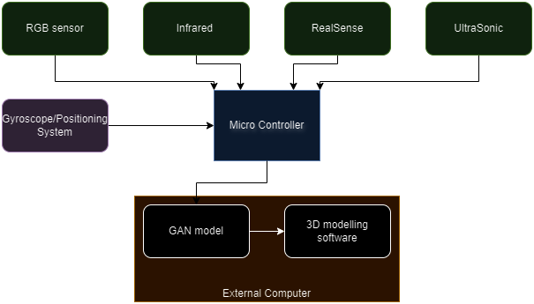

Figure 1: System Operations Overview

## 2.3 Referenced Documents and Citations

1. Figure 2: Wei, Y., Vosselman, G., Yang, M. Y., & University of Twente. (n.d.). Flow-based GAN for 3D Point Cloud generation. In the University of Twente [Journal-article]. https://weiyao1996.github.io/files/publications/BMVC_2022.pdf
2. Versatile and Scalable 3D RGB Point Cloud Generation from 2D Images in Unsupervised Reconstruction.
3. Point Cloud Segmentation Using RGB Drone Imagery.

# 3. Operating Concept

## 3.1 Scope

This report covers the development and integration of GAN models for different sensor types: RGB, Infrared (IR), Realsense/Kinect (RGB-D), and Ultrasonic. It includes details on responsibilities, tasks, deliverables, and the timeline for the project.

## 3.2 Operational Description

Tasks: Combine point clouds from various sensors into a cohesive 3D model. Visualize and optimize the integrated 3D model in digital twin environments (Gazebo/Unity). Figure 2 provides an example that relates to our task goals, but we will be visualizing an environment instead of an object.

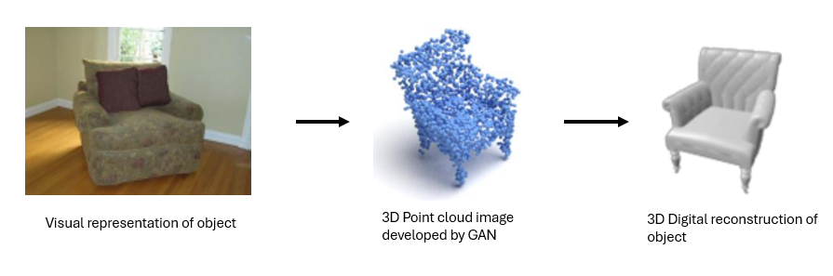

Figure 2: Example of Digital 3D Reconstruction of an Object.

## 3.3 System Description

### 3.3.1 RGB

A GAN model will be developed that converts RGB images to 3D point clouds. RGB data will be preprocessed to optimize input for the GAN. The RGB sensor allows the ability to train the GAN model to convert from RGB to point cloud in order to integrate into the final 3D model.

#### 3.3.1.1 Existing Technologies

Currently, there exists a technology that utilizes CNN layers and diffusion-denoising approaches. Convolutional neural networks use several layers to maintain relevant information without causing a storage issue.

#### 3.3.1.2 Alternative Methods

Our RGB will use machine learning algorithms to train the model in order to develop a GAN model. This model will be trained to preprocess RGB data; this will help with processing speed as well as the reliability of the model.

### 3.3.2 Infrared

The Infrared sensor will capture thermal imaging of the environment in order to train the GAN model to create a 3D point cloud of said environment. This sensor will be able to accurately capture data in areas that the other sensors may not be able to perform as well, such as low-light environments.

#### 3.3.2.1 Existing Technologies

Infrared sensors are used quite often to create point clouds using LiDAR. The infrared sensor in these systems is used to calibrate the positioning of RGB points when generating a point cloud in an environment. They are also useful for making 3-D heat maps of large environments.

#### 3.3.2.2 Alternative Methods

The Infrared sensor in this case will be used to generate a point cloud using our GAN model which will be used later to combine with the model output of other sensors. This model will be trained on openly available infrared sensor data as well as data that will be captured using the sensor.

### 3.3.3 Realsense/Kinect

The RealSense/Kinect camera plays a pivotal role in capturing depth information, and when combined with its RGB imaging capabilities, it can independently generate a detailed 3D map of a room. This dataset is essential for the GAN model, as it enhances the depth data, enabling the creation of high-resolution point clouds for accurate and refined 3D reconstructions

#### 3.3.3.1 Existing Technologies

While Intel Realsense cameras are not widely used in common settings, researchers have found great use for them in tracking body movements for both human and animal applications. The Microsoft Kinect camera is a sensor that was sold along with the Xbox 360 and Xbox One as a tool for hands-free controls and gaming applications. Both of these devices are mainly used for tracking the movement of an object.

#### 3.3.3.2 Alternative Methods

Unlike the common uses for these sensors, we won’t be tracking the motion of objects, rather, the sensor’s depth-sensing camera will be used to determine the distance of objects to map the RGB camera input better.

### 3.3.4 Ultrasonic

The ultrasonic sensor collects data that provides information on the distance between objects using sound waves. While there will be extreme challenges in getting detailed information from this type of sensor in complex environments, it can be used extensively to confirm the accuracy of the developed information from other sensors such as a room/object's size, length, etc. Ultrasonic sensors do not need visibility, providing a solution to environments covered in smoke or dark.

#### 3.3.4.1 Existing Technologies

Ultrasonic sensors are used in a wide variety of applications in today's world. This includes obstacle detection for moving vehicles, liquid level measurements within containers such as wastewater treatment plants and water tanks, and even automatic security/door operations. Similar applications to this project include using ultrasonic sensors to map inaccessible areas and generate 3D environments. In regards to GAN model applications, these models are mostly used for image generation and 3D object generation.

#### 3.3.4.2 Alternative Methods

Gan models often generate brand-new, unique images from limited data sets. While using the ultrasonic sensor to collect various data points from any surrounding environment, the GAN model must be trained to recognize differences between objects, walls, and other surfaces from simple distance measurements.

## 3.4 Modes of Operations

### 3.4.1 Reconnaissance

The only mode of operation for this system is to perform reconnaissance in an emergency situation.

## 3.5 Users

Primary users would be first responders. The intended purpose of this system is to assist in an emergency situation, so the user would not need prior knowledge other than basic robotic control. The user would maneuver the robot around the room, capturing imagery using the sensors of the robot.

# 4. Scenarios

## 4.1. Search and Rescue

The primary scenario for which the robot is being designed is search and rescue missions. These operations often occur in hazardous or inaccessible areas, such as collapsed buildings, dense forests, or areas affected by natural disasters. The GAN robot, equipped with various sensors, can navigate these dangerous environments and generate real-time, high-resolution maps. The robot can use its GAN model to reconstruct partially occluded regions and enhance imaging data, allowing rescue teams to detect and locate victims faster without putting themselves at risk.

## 4.2. Cave Exploration

Exploring cave systems is challenging due to the lack of natural light and complex, often unstable, terrain. The GAN robot can utilize depth sensors, infrared cameras, and LiDAR to generate detailed 3D maps of the cave environment. Its GAN model can enhance low-resolution or incomplete sensor data to create a comprehensive view of the cave, helping explorers or researchers navigate safely while minimizing the risk of getting lost or encountering dangerous areas.

## 4.3. Sea-floor Mapping

Mapping the sea floor is crucial for marine research, underwater construction, and locating shipwrecks. Traditional methods using sonar or cameras can result in noisy or incomplete data due to water conditions. The GAN robot, equipped with underwater sensors, can enhance this data in real time, providing clearer and more accurate images of the sea floor.

## 4.4. Healthcare

While our GAN model is being developed to be used on robots, it is not limited to that use. For example, in healthcare, the GAN model can be used to improve medical imaging techniques. By generating high-resolution images from noisy or low-quality sensor data (such as MRIs, CT scans, or ultrasounds), GANs can help doctors make more accurate diagnoses.

# 5. Analysis

## 5.1 Summary of Proposed Improvements

A robot with these sensors can capture a 3D model of the environment more accurately with sensors backed by machine learning to create the 3D environment while being able to fill the gap caused by environmental factors for one or more sensors.

## 5.2 Constraints

Many different factors can lead to constraints in the operation of the system, as outlined in the table below.

| **Constraints** | **Reasoning** |
| --- | --- |
| 1) Microcontroller | The GAN model will be running on a microcontroller which limits the computation power of the model. |
| 2) Sensor Resolution | Sensor resolution can greatly affect the quality of the 3D model and different sensors can capture data in different ways. |
| 3) Time | The GAN model will be limited due to the limited training data and training times due to deadlines. |

Table 3: List of Design Constraints

## 5.3 Impact

This technology could have a great impact for mankind, as it would allow us to more accurately map areas before humans need to enter. The best example of this would be for first responders getting a 3D map of an environment and its hazards before people have to go into said environment. Another positive impact would be mapping and charting areas that are unknown or unsafe for humans such as caves or the ocean floor.

## 5.4 Risks and Mitigation

1. **Model Accuracy**: GAN models may not achieve the desired accuracy.
   1. *Mitigation*: Iterative testing and validation; explore alternative architectures.
2. **Integration Issues**: Difficulty in merging point clouds from different sensors.
   1. *Mitigation*: Early and continuous integration testing; effective communication within the team.
3. **Visualization Challenges**: Inaccurate or inefficient visualization of the 3D model.
   1. *Mitigation*: Regular feedback sessions; thorough testing in Gazebo/Unity.

## 5.5 Alternatives

There are other projects that are using sensor fusion and machine learning to create 3D point cloud maps, like Nvidia. However, these projects mainly focus on making a model based on RGB and Lidar data rather than the 4 sensors used here.

# Conclusion

This ConOps provides a comprehensive framework for the successful development and integration of GAN models for generating 3D point clouds from various sensor types. By adhering to this plan, the team will produce a unified 3D model and demonstrate its capabilities in a digital twin environment, contributing valuable insights and tools for 3D reconstruction and visualization

GAN Assisted Map Reconstruction for first responders using Sensor Fusion

Christian Jeardoe, Quinn Leboeuf,

Kyle Smejkal, Rufus Tadpatri

**Interface Control Document**

REVISION – 2

4 December 2024

Interface Control Document

for

GAN Assisted Map Reconstruction for first responders using Sensor Fusion

Approved by:

Rufus Tadpatri *12/04/2024*

_____________________________

Project Leader Date

_____________________________

John Lusher II, P.E. Date

_____________________________

T/A Date

**Change Record**

| **Rev.** | **Date** | **Originator** | **Approvals** | **Description** |
| --- | --- | --- | --- | --- |
| **1** | 10/01/2024 | GAN Assisted Map Reconstruction |  | Draft Release |
| **2** | 12/04/2024 | GAN Assisted Map Reconstruction |  | Final Version |

**Table of Contents**

**1. Overview 7**

**2. References and Definitions 8**

2.1. References 8

2.2. Definitions 8

**3. Physical Interface 9**

3.1. Weight 9

3.2. Dimensions 9

3.3. Mounting Locations 10

3.3.1. Intel RealSense Mounting Points 10

3.3.2. MLX90640 Thermal Camera Mounting Points 10

3.3.3. HC-SR04 Ultrasonic Sensor Mounting 10

**4. Thermal Interface 10**

**5. Electrical Interface 11**

5.1. Primary Input Power 11

5.1.1. Primary Power Input for RealSense Subsystem 11

5.1.2. Primary Power Input for Thermal Camera Subsystem 11

5.1.3. Primary Power Input for RGB Camera Subsystem 11

5.1.4. Primary Power Input for Ultrasonic Subsystem 11

5.2. Signal Interfaces 11

5.2.1. Signal Interface for RealSense Subsystem 11

5.2.2. Signal Interface for Ultrasonic Subsystem 11

5.3. Video Interfaces 12

5.3.1 Video Interface for RealSense Subsystem 12

5.3.2 Video Interface for RGB Subsystem 12

5.4. User Control Interface 12

5.4.1 User Control Interface for RealSense Subsystem 12

5.4.2 User Control Interface for Thermal Camera Subsystem 12

5.4.3 User Control Interface for RGB Camera Subsystem 13

5.4.4 User Control Interface for Ultrasonic Subsystem 13

5.5. Microcontroller Pin Interface 13

5.5.1. Microcontroller Pin Interface for the Thermal Camera Subsystem 13

5.5.2. Microcontroller Pin Interface for the Ultrasonic Sensor Subsystem 13

**6. Communications / Device Interface Protocols 14**

6.1. Host Device 14

6.1.1. Host Device for the RealSense Subsystem 14

6.1.2. Host Device for the RGB Subsystem 14

6.1.3. Host Device for Thermal Camera Subsystem 14

6.1.4. Host Device for Ultrasonic Sensor Subsystem 14

6.2. Video Interface 14

6.2.1. Video Interface for the RealSense Subsystem 14

6.2.1. Video Interface for the RGB Subsystem 15

6.3. Device Peripheral Interface 15

**List of Tables**

**Table 1:** Weights of Components Used in Project 9

**Table 2:** Dimensions of Components Used in Project 9

**Table 3:** Ultrasonic Sensor Pin Interface 12

# **Overview**

# The Interface Control Document (ICD) for the GAN-assisted sensor fusion map reconstruction project for first responders will outline how components from the Concept of Operations (ConOps) and Functional System Requirements (FSR) are developed and integrated. It will cover the GAN architecture, sensor input/output formats, preprocessing steps, computational needs (GPU/CPU), and model deployment workflow. Additionally, it will detail the interaction between GAN subsystems, including data flow, training processes, and evaluation metrics, ensuring alignment with the goals and requirements in the FSR and ConOps.

1. **References and Definitions**
   1. ***References***

**OpenCV Documentation (v4.5.5)**

**Computer Vision Library Reference**

Released Apr 2021

**PyTorch Framework Documentation (v2.0)**

**Machine Learning Framework for Neural Networks**

Updated Mar 2024

**Intel RealSense SDK 2.0**

**Software Development Kit for RealSense Cameras**

Updated Oct 2024

**PyRealSense2**

**PyRealSense2 Python Wrapper Documentation**

Updated Oct 2024

**Waveshare MLX90640-D55 Thermal Camera Overview**

**Documentation for thermal camera**

**PlayStation 12240 PS3 Eye Camera Overview**

**Documentation for RGB camera**

**Code Laboratories Eye Platform Driver**

**Software for RGB camera**

* 1. ***Definitions***

GAN Generative Adversarial Network

FPS Frames Per Second

SDK Software Development Kit

CL Code Laboratories

I2C Inter-Integrated Circuit

PS Play Station

V Volts

A Amps

mA MilliAmps

# **Physical Interface**

# ***Weight***

Due to this project’s inherent software nature, there are only a few components that are being physically used.

**Table 1:** Weights of Components Used in Project

| **Component** | **Weight** |
| --- | --- |
| Intel Realsense Camera | 2.54 oz |
| HP OMEN Laptop | 4.68 lbs |
| MLX90640 Thermal Camera | 0.2 oz |
| Raspberry Pi 3 | 1.48 oz |
| Arduino Uno R3 | 0.88 oz |
| HC-SR04 Ultrasonic Sensor | 0.3 oz |
| Dell XPS Laptop | 2.6 lbs |
| PS3 Move Eye Camera (RGB Sensor) | 4.79 oz |

# ***Dimensions***

**Table 2:** Dimensions of Components Used in Project

| **Component** | **Diameter** | **Length** | **Width** | **Height** |
| --- | --- | --- | --- | --- |
| Intel Realsense Camera | N/A | 3.54 “ | 0.98 “ | 0.98 “ |
| HP OMEN Laptop | N/A | 15.07 “ | 9.67 “ | 0.61 “ |
| Intel Realsense USB 3.1 Cable | 0.20 “ | 2.5 “ | N/A | N/A |
| Raspberry Pi 3 | N/A | 3.35 “ | 2.2 “ | 0.8 “ |
| MLX90640 Thermal Camera | N/A | 1.1 “ | 0.63 “ | 0.47 “ |
| Arduino Uno R3 | N/A | 2.7 “ | 2.1 “ | N/A |
| HC-SR04 Ultrasonic Sensor | N/A | 1.77 “ | 0.787 “ | 0.591 “ |
| Dell Precision 5540 | N/A | 9.26 “ | 14.06 “ | 0.44 “ |
| Dell XPS Laptop | N/A | 11.62 ” | 7.84 ” | 0.60 ” |
| PS3 Move Eye Camera (RGB Sensor) | N/A | 3.31 ” | 2.64 ” | 2.24 ” |

# ***Mounting Locations***

* + 1. **Intel RealSense D435 Mounting Points**

The Intel Realsense D435 Camera has two mounting points, one for a single 1/4-20 UNC thread and two for an M3 thread mount.

* + 1. **MLX90640 Thermal Camera Mounting Points**

The MLX90640 Thermal Camera has two points, both are 2mm located on the camera side of the PCB

* + 1. **HC-SR04 Ultrasonic Sensor Mounting**

The HC-SR04 has a separate mounting device designed specifically for a servo motor. This will be mounted in conjunction with an RGB camera for 360 degree room scanning to collect model training data as well as input data.

# **Thermal Interface**

Our project has very few heating concerns. The cameras will heat up when in use, noticeable to the touch, but not to the point of failure. No additional cooling or heating requirements will be needed at this stage of the project.

# **Electrical Interface**

# ***Primary Input Power***

* + 1. **Primary Power Input for RealSense Subsystem**

The RealSense subsystem will draw power directly from the USB 3.1 port on the HP Omen laptop. The laptop itself will be powered either by its internal 12V battery for portability or through a standard wall outlet using its 120W charger for extended operation.

* + 1. **Primary Power Input for Thermal Camera Subsystem**

The MLX90640 operates between 3.3V and 5V with <23 mA which is provided by pin 4 on the Raspberry Pi 3. The Raspberry Pi itself requires 5V and 2.5A which can be provided via Micro USB.

* + 1. **Primary Power Input for RGB Camera Subsystem**

The RGB subsystem draws power directly from the Dell XPS laptop through the USB-C power via a USB-C to USB adapter. The laptop itself will be powered either by its internal 12V battery for portability or through a standard wall outlet using its 120W charger for extended operation.

* + 1. **Primary Power Input for Ultrasonic Subsystem**

The HC-SR04 ultrasonic sensor utilizes a 5 volt power supply from the Arduino itself (which draws its own power from a precision 5540 Dell laptop), as well as a current of 15 mA. The Arduino is connected to a computer through a 3M Arduino UNO USB data sync cable.

# ***Signal Interfaces***

* + 1. **Signal Interface for RealSense Subsystem**

The Intel RealSense D435 camera is connected to an HP Omen laptop through a USB 3.1 port, ensuring high-speed data transfer rates required for real-time depth map and RGB image acquisition. The USB 3.1 interface supports a data transfer rate of up to 10 Gbps, enabling the subsystem to handle the bandwidth demands of high-resolution depth and color streams. The stability and throughput of the USB 3.1 connection are critical for achieving seamless sensor data fusion and processing during operation.

* + 1. **Signal Interface for Ultrasonic Subsystem**

The pin configuration and other electrical characteristics are shown in the table below. The TRIG signal requires a 10-microsecond high pulse to begin measuring. The Sensor then emits 40 kHz ultrasonic bursts upon receiving the pulse. The ECHO pin outputs a high pulse, used to calculate the distance in centimeters. These pins are configured via an Arduino IDE connected through the USB 2.0 cable type A to B Male for Arduino.

**Table 3:** Ultrasonic Sensor Pin Interface

| **Pin** | **Number** | **Description** |
| --- | --- | --- |
| 1 | Vcc | Power supply |
| 2 | TRIG | Trigger pin (input) |
| 3 | ECHO | Echo pin (output) |
| 4 | GND | Ground Connection |

# ***Video Interfaces***

* + 1. **Video Interface for RealSense Subsystem**

The RealSense camera’s video feed (both depth and RGB) is displayed in real-time on the HP Omen via the RealSense SDK 2.0. The video feed allows you to see what exactly the camera is seeing, which helps with testing. Along with this, via OpenCV, you can display the generated point cloud in a 3D environment where it can be manipulated.

* + 1. **Video Interface for RGB Subsystem**

The RGB camera’s video feed is displayed in real-time on the Dell XPS laptop via the CL-Eye Test program. The video feed allows you to see what exactly the camera is seeing, which helps with testing. Along with this, via OpenCV, you can display the generated point cloud in a 3D environment where it can be manipulated.

# ***User Control Interface***

* + 1. **User Control Interface for RealSense Subsystem**

The UI for the RealSense subsystem is currently all within the Windows command prompt (CMD). The training program is all automated; it just needs to be executed, same for the inference program. The data collection program requires the press of either the ‘s’ key to save an image or the press of the ‘q’ to quit the program. The point cloud generating program requires the press of the ‘e’ key to save a .PLY file and a press of the ‘q’ key to quit the program. Finally, the point cloud displayer is also fully automated, it just needs to be executed after the generator.

* + 1. **User Control Interface for Thermal Camera Subsystem**

The UI for the Thermal Camera Subsystem is all through a Python program. Upon starting the program, the camera boots up and refreshes at a rate set in the program between 0.5 and 64 Hz. The data is formatted as an array and needs to be reformatted into the dimensions of the camera and saved. The program captures thermal images at the set refresh rate until the ‘q’ key is pressed. The images are saved as ‘.png’ and transferred to the computer with the GAN model via a USB storage device.

* + 1. **User Control Interface for RGB Camera Subsystem**

The UI for the RGB camera runs through a Microsoft Visual Studios python script. Upon execution of the program, the user will set up the sensor and press the ‘s’ key to capture an image or press the ‘q’ key to quit the program. Once an image has been captured, the point cloud generation will begin automatically. After about 10-15 seconds, the point cloud will open up and the user can use the mouse to maneuver around the 3d environment displayed.

* + 1. **User Control Interface for Ultrasonic Subsystem**

The UI for the ultrasonic sensor uses Arduino API to design the triggers for pins and collect consecutive distance measurements. Using the Arduino IDE, the code for a similar ultrasonic sensor is already given, which can be edited to accommodate for the HC-SR04 pins. Distance is rapidly calculated through the formula:

$Distance (cm) =(Pulse Width (μs) × 0.034) / 2​$

The result will be displayed using Serial.print(). A delay of at least 60 milliseconds between measurements will be added for stability.

# **Microcontroller Pin Interface**

* + 1. **Microcontroller Pin Interface for the Thermal Camera Subsystem**

The MLX90640 Thermal Camera has 4 pins connected to the Raspberry PI 3. VCC, GND pin for the power supply, VCC connected to the control 3.3V or 5V power supply, GND corresponds to the connection of the GND. SDA is the data pin of I2C, connected to the GPIO 8 pin 3 of the Raspberry PI 3, without an external pull-up resistor. SCL is the clock pin of I2C, connected to the GPIO 9 pin 5 of the Raspberry PI 3, without an external pull-up resistor.

* + 1. **Microcontroller Pin Interface for the Ultrasonic Sensor Subsystem**

The Pin interface used on the Arduino Uno is based on the ultrasonic sensor pin interface shown in table 3. There are 4 pins used on the microcontroller. The 5V and GND pins are used to power the ultrasonic sensor, and pins 9 and 10 were used to connect the sensor TRIG and ECHO regions (though, any pin 2 through 13 can be used for this connection).

# **Communications / Device Interface Protocols**

# ***Host Device***

* + 1. **Host Device for the RealSense Subsystem**

The host device for the project is an HP Omen laptop equipped with USB 3.1 ports, an AMD 2600X CPU, and an Nvidia 960M GPU. The host runs Windows 10 and interfaces with the Intel RealSense D435 camera through the RealSense SDK 2.0, specifically the pyrealsense2 wrapper. Communication between the host and the device is managed using USB 3.1 protocols, ensuring high-speed data transfer and efficient utilization of hardware resources. The host also manages data preprocessing, GAN model inference, 3D point cloud generation, and performance evaluation.

* + 1. **Host Device for the RGB Subsystem**

The host device for the RGB subsystem is a Dell XPS laptop. The host runs Windows 10 and interfaces with the PS3 Move Eye Camera through the CL-Eye Test program. Communication between the host and the device is managed through the USB connection, ensuring high-speed data transfer and efficient utilization of hardware resources. The host also manages data preprocessing, GAN model inference, 3D point cloud generation, and performance evaluation.

* + 1. **Host Device for Thermal Camera Subsystem**

The host device for the Thermal Camera subsystem is a Dell Precision 5520 laptop. The host runs Windows 10 and interfaces with the MLX90640 thermal camera through a Raspberry PI 3.

* + 1. **Host Device for Ultrasonic Sensor Subsystem**

A Dell Precision 5540 is used in conjunction with the Arduino Uno to host the Ultrasonic sensor data collection. This device also is used for the use of the GAN model, including training and data processing. Device programs include VScode for GAN model development and the Arduino IDE for data collection.

# ***Video Interface***

* + 1. **Video Interface for the RealSense Subsystem**

The video interface between the RealSense D435 camera and the host laptop uses a USB 3.1 connection. The interface streams synchronized depth and RGB video data at resolutions of up to 1280x720 for depth and 1920x1080 for RGB, although for our purposes this has been turned down to 640x480 for both. The video feed is captured at 30 FPS for both depth and RGB. Video data is encoded using the camera's internal processing and sent as raw image frames, which are decoded on the host.

* + 1. **Video Interface for the RGB Subsystem**

The video interface for the PS3 Move Eye camera has a resolution at 640x480 pixels. The video feed is captured at 60 frames per second. Video data is encoded using the camera's internal processing and sent as raw image frames, which are decoded on the host.

# ***Device Peripheral Interface***

The USB 3.1 Gen 1 protocol is used for the RealSense camera. The host interacts with these peripherals through the RealSense SDK, which abstracts the low-level protocols and provides high-level APIs for controlling camera parameters and retrieving depth and RGB streams. The communication protocol of MLX90640 Thermal Camera is I2C, which supports I2C high-speed mode (up to 1MHz), and can only be used as a slave device on the I2C bus. The HC-SR04 ultrasonic sensor interfaces with a microcontroller via a digital output TRIG pin for initiating measurements and a digital input ECHO pin for receiving the reflected signal duration, powered by 5V and GND.

GAN Assisted Map Reconstruction for first responders using Sensor Fusion

Christian Jeardoe, Quinn Leboeuf,

Kyle Smejkal, Rufus Tadpatri

**Functional System Requirements**

REVISION – 2

4 December 2024

Functional System Requirements

for

GAN Assisted Map Reconstruction for first responders using Sensor Fusion

Approved by:

Rufus Tadpatri *12/04/2024*

_____________________________

Project Leader Date

_____________________________

John Lusher, P.E. Date

_____________________________

T/A Date

**Change Record**

| **Rev.** | **Date** | **Originator** | **Approvals** | **Description** |
| --- | --- | --- | --- | --- |
| **1** | 10/01/2024 | GAN Assisted Map Reconstruction |  | Draft Release |
| **2** | 12/04/2024 | GAN Assisted Map Reconstruction |  | Final Version |

**Table of Contents**

**1.** **Introduction 7**

1.1. Purpose and Scope 7

1.2. Responsibility and Change Authority 8

**2.** **Applicable and Reference Documents** 9

2.1. Applicable Documents 9

2.2. Reference Documents 9

2.3. Order of Precedence 9

**3.** **Requirements 10**

3.1. System Definition 10

3.2. Characteristics 11

3.2.1. Functional / Performance Requirements 11

3.2.2. Electrical Characteristics 12

3.2.3. Failure Propagation 12

**4.** **Support Requirements 13**

**Appendix A Acronyms and Abbreviations 11**

**Appendix B Definition of Terms 12**

**List of Tables**

**Table 1:** Applicable Documents 9

**Table 2:** Reference Documents 9

**List of Figures**

**Figure 1:** Project Conceptual Image7

**Figure 2:** Block Diagram of System10

# 

# **Introduction**

## ***Purpose and Scope***

The purpose of this project is to develop a GAN-assisted system for sensor fusion and depth map reconstruction, designed to enhance situational awareness for first responders in critical environments. Leveraging data captured by RealSense, RGB, Inferred, and Ultrasonic sensors the system shall generate accurate, high-quality virtual twins of the environment by reducing noise and filling in missing data, addressing limitations in raw sensor output. The project should encompass the integration of several GAN models and preprocessing pipelines to deliver real-time or near-real-time point cloud generation and enhancement. The scope of this project includes designing and implementing the communication protocols, data processing workflows, and evaluation metrics necessary to ensure the system operates reliably in both controlled and dynamic scenarios. This solution is intended to support applications such as navigation in low-visibility environments, obstacle detection, and spatial mapping, contributing to the safety and efficiency of first responder operations.

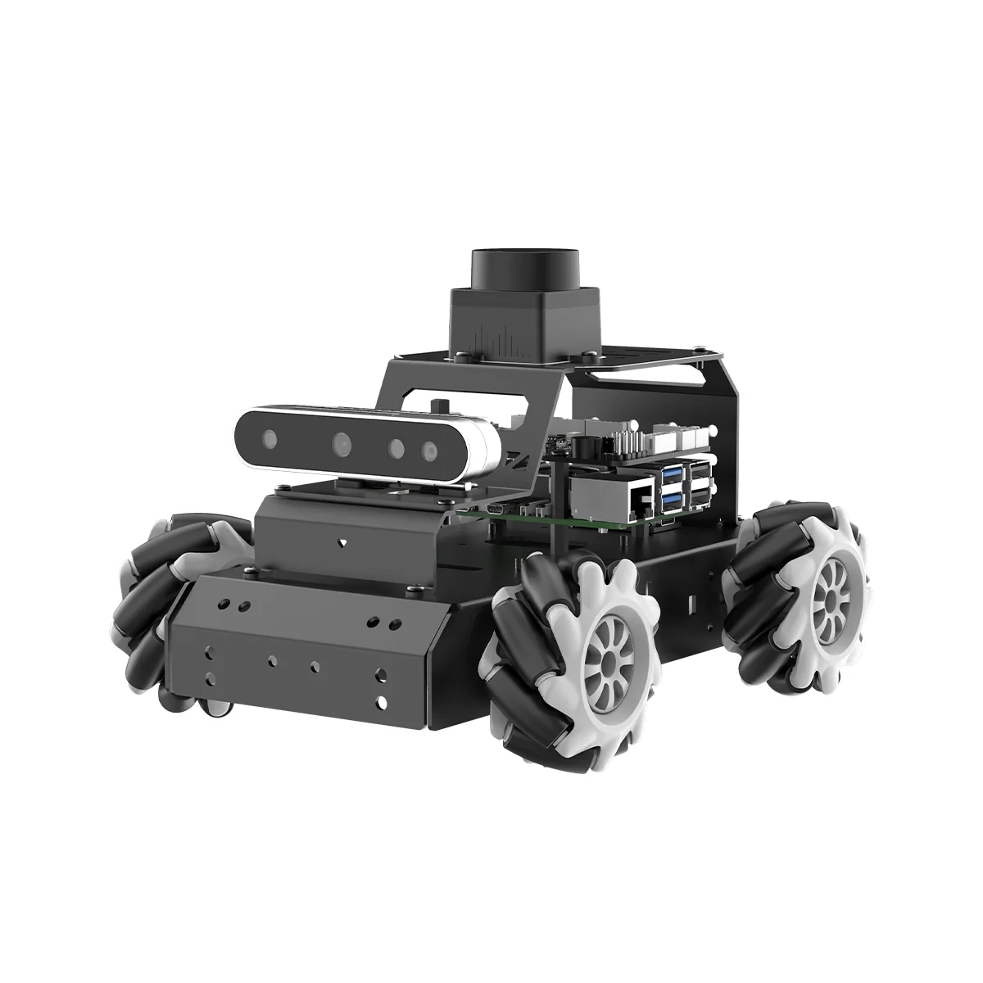

**Figure 1: Project Concept Image**

## ***Responsibility and Change Authority***

Our team leader, Rufus Tadpatri, is charged with ensuring all specifications of the system are met. Any changes to the specifications or deliverables of the project must be approved by the team leader, Rufus Tadpatri, and our sponsor/TA, Swarnabha Roy.

# **Applicable and Reference Documents**

## ***Applicable Documents***

The following documents, of the exact issue and revision shown, form a part of this specification to the extent specified herein:

**Table 1: Applicable Documents**

| **Document Number** | **Revision/Release Date** | **Document Title** |
| --- | --- | --- |
| [1] | 12/10/2023 | Versatile and Scalable 3D RGB Point Cloud Generation from 2D Images in Unsupervised Reconstruction |
| [2] | 2020 | Point Cloud Segmentation Using RGB Drone Imagery |

## ***Reference Documents***

The following documents are reference documents utilized in the development of this specification. These documents do not form a part of this specification and are not controlled by their reference herein:

**Table 2: Reference Documents**

| **Document Number** | **Revision/Release Date** | **Document Title** |
| --- | --- | --- |
| OpenCV-4.5.5 | April 2021 | OpenCV Documentation v4.5.5 |
| PyTorch-2.0 | March 2024 | PyTorch Framework Documentation v2.0 |
| IntelRS-SDK-2.0 | October 2024 | Intel RealSense SDK 2.0 |
| PyRealSense2 | October 2024 | PyRealSense2 Python Wrapper Documentation |
| MLX90640 Wiki | July 2024 | Waveshare MLX90640-55 Thermal Camera overview |

## ***Order of Precedence***

In the event of a conflict between the text of this specification and an applicable document cited herein, the text of this specification takes precedence without any exceptions.

All specifications, standards, exhibits, drawings or other documents that are invoked as “applicable” in this specification are incorporated as cited. All documents that are referred to within an applicable report are considered to be for guidance and information only, except ICDs that have their relevant documents considered to be incorporated as cited.

# **Requirements**

## ***System Definition***

The finished product will be a robot that will maneuver around a room/environment. Four individual subsystems with four different sensors will scan the surroundings and generate a 3D point cloud. The four different sensors are an RGB sensor, an infrared sensor, a RealSense sensor, and an ultrasonic sensor.

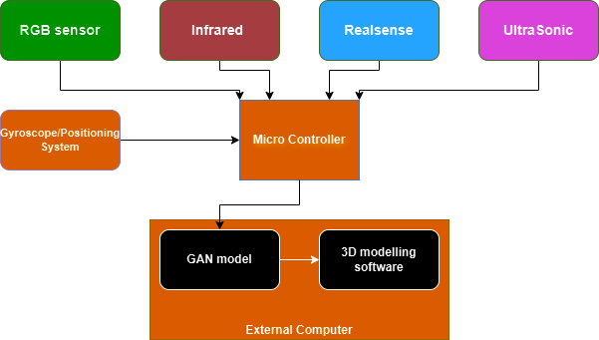

**Figure 2. Block Diagram of System**

This block diagram illustrates the high-level structure of how each subsystem is interconnected. Each sensor will provide its input to a microcontroller, along with an inertial measurement unit (IMU). The microcontroller will organize the data and transmit it to an external computer. The computer will run each subsystem’s individual GAN model, processing the data streams. The final output will then be fed into 3D modeling software to visualize the 3D twin environment being created.

## ***Characteristics***

### **Functional / Performance Requirements**

#### **Requirements**

**3.2.1.1.1. Robot Maneuvering**

The robot that will be used to carry the sensors should have accurate navigation for merging of generated point cloud images. The robot must reliably avoid obstacles and be capable of movement on various terrain. Current operable terrains mainly include those found within indoor environments (hardwood, carpet, etc.). Future improved terrain maneuverability could include grass/dirt, jagged rock, and sand.

**3.2.1.1.2. Sensor Fusion**

Sensors should work together to output highly accurate 3D images of the scanned environment. All sensors should not only work individually, but also all be capable of providing data for 3D image improvement in conjunction with each other. The system should also be capable of understanding when specific sensors are not working properly. This can be a malfunction in the sensor itself, or the sensor is in an environment where it cannot properly collect data (RGB sensor cannot collect data in a dark room). Remaining sensors that are still functional in such situations will still be capable of working together to develop 3D maps without needing the non-functional sensor data.

**3.2.1.1.3. 3D Image Output**

The system should be capable of creating a 3D map no matter the type of environment or conditions. Whether just 1 or all 4 sensors are working, a 3D image output should always be produced. This image will generate in real time and be improved as more data is collected from the sensors that are moving around some enclosed area.

#### **Distance Requirements**

The system as a whole can only accurately create a point cloud of objects within 3 meters due to the limitations of each individual sensor.

*Rationale: The optimal range for the depth sensor of the RealSense camera is .3 to 3 meters. The optimal range for the MLX90640 thermal camera is .5 to 5 meters. The optimal range for the Ultrasonic sensor is around 4 meters.*

### **3.2.2. Electrical Characteristics**

#### **Inputs**

1. All input data for the GAN model is received through each of the four subsystem sensors.

*Rationale: GAN models are developed to accommodate data received specifically from their corresponding sensors*

##### **External Commands**

Commands come in from each subsystem’s control system, whether being a microcontroller or a laptop device.

*Rationale: GAN models are developed to accommodate data received specifically form their corresponding sensors*

#### **Outputs**

##### **Data Output**

Outputs for each subsystem will be a 3D point cloud. The point cloud will open on each laptop as an openCV.

*Rationale: Each GAN model should be capable of creating its own point cloud without help from other sensor’s data or their corresponding GAN model outputs.*

##### **Raw Video Output**

The project shall include a raw video interface to support external recording.

*Rationale: Raw video helps ensure the system is working properly and sensor data aligns with corresponding RGB images for the environment.*

**3.2.2. Failure Propagation**

The system shall not allow propagation of faults beyond the project specification interface.

#### **Failure Detection, Isolation, and Recovery (FDIR)**

Failure detection for each individual system is required for the system to function properly. Each sensor must know when another sensor is inoperable, and accommodate for lack of said sensor data. Failure of sensors is expected based on environmental factors, so recovery is not necessarily needed in these situations. Sensors are individually isolated if failing, and if only one sensor is remaining, the remaining sensor is isolated to be used as the primary data retriever for the GAN model and the corresponding 3D image generation.

# **Support Requirements**

In addition to the four sensors, a computer that is powerful enough to render and display 3D graphics is needed for this system. The computer will also be tasked with executing all four GAN models at one time, generating images for each simultaneously.

# **Appendix A: Acronyms and Abbreviations**

FOV Field of View

GUI Graphical User Interface

Hz Hertz

ICD Interface Control Document

mA Milliamp

MHz Megahertz (1,000,000 Hz)

USB Universal Serial Bus

GAN Generative Adversarial Network

# **Appendix B: Definition of Terms**

Epoch:

One complete pass of the entire training dataset through the learning algorithm.

GAN Model:

A machine learning model that creates new data that resembles training data.

Cycle Consistency Loss:

A loss function used in GAN training to ensure that transformations between domains (e.g., depth to RGB and back) preserve structural integrity.

Digital Twin:

A virtual representation of a physical object or system, used for simulation, analysis, and visualization of the robot's 3D reconstruction.

Intrinsic Matrix:

A matrix that contains the camera's internal parameters, used to map 3D points into 2D image coordinates.

GAN Assisted Map Reconstruction for first responders using Sensor Fusion

Christian Jeardoe, Quinn Leboeuf,

Kyle Smejkal, Rufus Tadpatri

**Validation**

REVISION – 1

5 December 2024

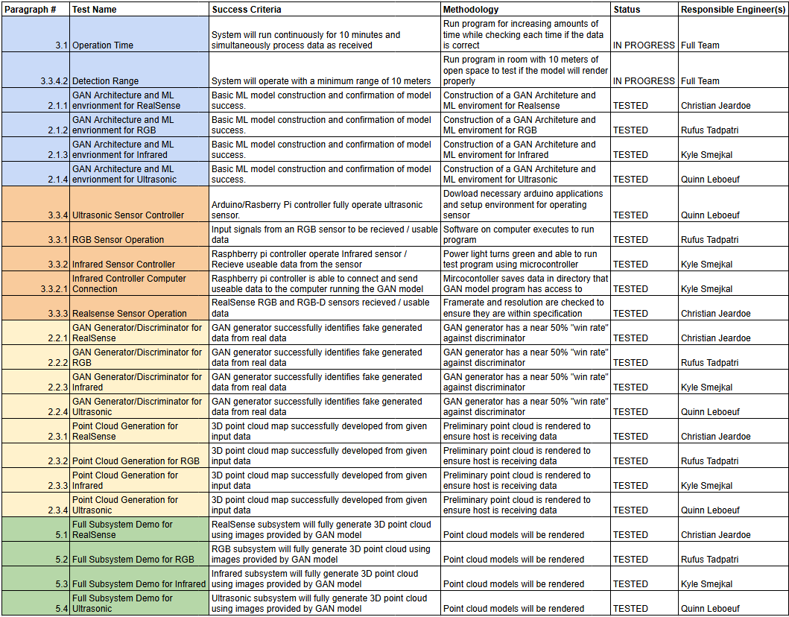

GAN Assisted Map Reconstruction for first responders using Sensor Fusion

Christian Jeardoe, Quinn Leboeuf,

Kyle Smejkal, Rufus Tadpatri

**Timeline**

REVISION – 1

5 December 2024

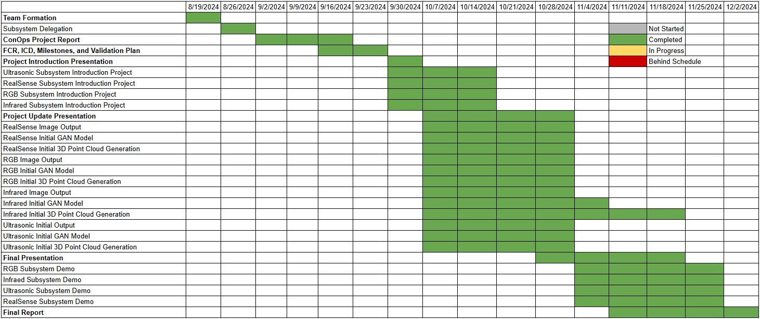

GAN Assisted Map Reconstruction for first responders using Sensor Fusion

Christian Jeardoe, Quinn Leboeuf,

Kyle Smejkal, Rufus Tadpatri

**Subsystem Reports**

Subsystem reports

for

GAN Assisted Map Reconstruction for first responders using Sensor Fusion

Approved by:

Rufus Tadpatri 12/04/2024

_____________________________

Project Leader Date

_____________________________

John Lusher, P.E. Date

_____________________________

T/A Date

**Change Record**

| **Rev.** | **Date** | **Originator** | **Approvals** | **Description** |
| --- | --- | --- | --- | --- |
| **1** | 12/04/2024 | GAN Assisted Map Reconstruction |  | Final Version |

**Table of Contents**

**1. Introduction 7**

**2. RealSense Sensor Subsystem Report (Christian Jeardoe, 129001487) 8**

2.1. Subsystem Introduction 8

2.2. Subsystem Details 8

2.3. Subsystem Validation 10

2.4. Subsystem Conclusion 12

**3. RGB Sensor Subsystem Report (Rufus Tadpatri 830003175)** **13**

3.1. Subsystem Introduction 13

3.2. Subsystem Details 13

3.3. Subsystem Validation 13

3.4. Subsystem Conclusion 15

**4. Thermal Sensor Subsystem Report (Kyle Smejkal 627002694) 16**

4.1. Subsystem Introduction 16

4.2. Capturing Thermal Data 16

4.3. Training the GAN model 17

4.4. Point Cloud Generation 19

4.5. Subsystem Validation and Conclusion 20

**5. Ultrasonic Sensor Subsystem Report (Quinn LeBoeuf, 529007084)** **21**

5.1. Subsystem Introduction 21

5.2. Data Retrieval and Processing 21

5.3. GAN Model Structure and Training 21

5.4. Subsystem Validation 22

5.4.1 Data Retrieval Validation 22

5.4.2 GAN Model Training Validation 23

5.4.3 GAN Model Operation Validation 23

5.5. Subsystem Conclusion 24

**List of Tables**

**Table 1:** Specifications for RGB camera 9

**Table 2:** Specifications for Depth Sensor 9

**Table 3:** MLX90640 Thermal Camera Specifications 18

**List of Figures**

**Figure 1:** High Level Block Diagram of RealSense Subsystem8

**Figure 2:** Left, Centered, and Right Viewing Angles of 3D Point Cloud10

**Figure 3:** Screenshot of Terminal Showing Generator Loss Vs Discriminator Loss 10

**Figure 4:** Display of Both Cameras When Running 11

**Figure 5:** Raw Depth Map Input 11

**Figure 6:** Enhanced Depth Map Output 11

**Figure 7:** Input image into RGB Subsystem 14

**Figure 8:** Output 3D Point Cloud 14

**Figure 9:** Output 3D Point Cloud Alternate Angle 14

**Figure 10:** Pinout of Thermal Camera connection 16

**Figure 11:** Discriminator Architecture 18

**Figure 12:** Generator Architecture 18

**Figure 13:** Camera Intrinsics Example 19

**Figure 14:** Thermal Image Example 20

**Figure 15:** Depth Image example 20

**Figure 16:** Point Cloud Example 20

**Figure 17:** Different angle of Point Cloud 20

**Figure 18:** GAN model training and usage implementation 22

**Figure 19:** Generator and Discriminator Losses During Training Test 23

**Figure 20:** Trained GAN Model Input and Output Results 24

1. **Introduction**

Our project, GAN-Assisted Map Reconstruction for First Responders Using Sensor Fusion, is divided into four distinct sensor subsystems: RGB, RealSense, Infrared, and Ultrasonic. Each subsystem is equipped with its own input sensor and dedicated GAN model, each tailored to perform specific functions. Together, these subsystems will provide a continuous stream of data to generate a 3D virtual twin of any environment. All subsystems currently meet their requirements and operate as expected. Moving forward, each subsystem will undergo further refinement and has a well-defined plan for integration to achieve full sensor fusion.

## **RealSense Sensor Subsystem Report (Christian Jeardoe, 129001487)**

### **Subsystem Introduction**

The RealSense sensor subsystem serves as the primary sensor for our project. It captures both RGB and depth map images of the surrounding environment and utilizes a Generative Adversarial Network (GAN) model to enhance the raw depth map by smoothing noise and filling in missing data. Additionally, the subsystem processes the enhanced depth map to generate a detailed 3D point cloud representation, providing accurate spatial information for further analysis and applications.

### **Subsystem Details**

* + 1. **Subsystem Design**

The following is a high level block diagram of this subsystem.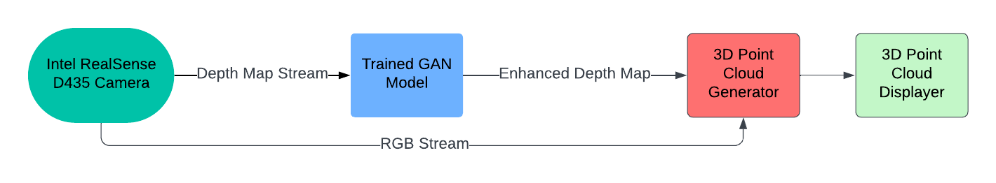

**Figure 1:** High Level Block Diagram of RealSense Subsystem

* + 1. **Subsystem Camera Specifications**

This subsystem starts with the Intel RealSense D435 RGB-D camera. This table shows the specifications for the camera's sensors.

| Resolution | 1920 x 1080 |
| --- | --- |
| Frame Rate | 30 fps |
| FOV | 69 x 42 |

**Table 1:** Specifications for RGB camera

| Resolution | 1270 x 720 |
| --- | --- |
| Frame Rate | 90 fps |
| FOV | 87 x 58 |
| Depth Accuracy | <2% at 2m |
| Ideal Range | .3m to 3m |

**Table 2:** Specifications for Depth Sensor

With these specifications it was determined the best specifications for this subsystem was 640x480 resolution, this was done to make the training of the model less computationally intensive and decrease generation time when feeding the trained model a depth map to enhance. Similarly, the video streams are capped at 30 fps to ensure both depth images and RGB images are synchronized.

* + 1. **Subsystem GAN Model Design, Training, and Use**

The GAN model for this subsystem was designed based on a Convolutional Neural Network (CNN) architecture with elements of a U-Net like design for the Generator. This type of architecture is often used in GANs for enhancement tasks like this. The Discriminator model is a CNN inspired design as well, used for binary classification.

The GAN model is trained on just over 700 depth map images collected using the RealSense camera. Each of these depth maps are copied and have “masks” placed over them which removes data from the original image. The original image and masked image are then used together in the generator to “teach” it to fill in that missing image data. The theory behind this is that if it can be taught to fill in missing, purposefully removed data, it will be able to fill in the inherent missing data that comes from raw depth map images. The Generator then sends either its own generated image, the “fake” one, or one of the unmasked “real” images to the discriminator where it needs to determine if its “real” or “fake”, using its binary classification. It will do this in a sequence of 20 epochs which take about 3-4 hours to complete. Once it is done, it generates a .PTH file which serves a model state save, meaning it can be loaded into another program to use the trained Generator.

To use the trained Generator, its .PTH file is loaded into another program where the now trained Generator can take in a raw input from the RealSense depth camera and generate an enhanced version of that depth map.

* + 1. **Subsystem 3D Point Cloud Generator and Viewer**

The 3D Point Cloud Generator takes in RGB and Depth streams, ensures the pipeline receives both types of frames before moving to the next set, aligns the two frames, maps the RGB color pixels on to that of the depth map points, and saves/exports the colored point cloud into a .PLY file. This file can then be imported into the 3D point cloud viewer and via OpenCV, be displayed in a 3D environment where the image can be manipulated. The following is an example of a .PLY file that was generated during lab being displayed.

**Figure 2:** Left, Centered, and Right Viewing Angles of 3D Point Cloud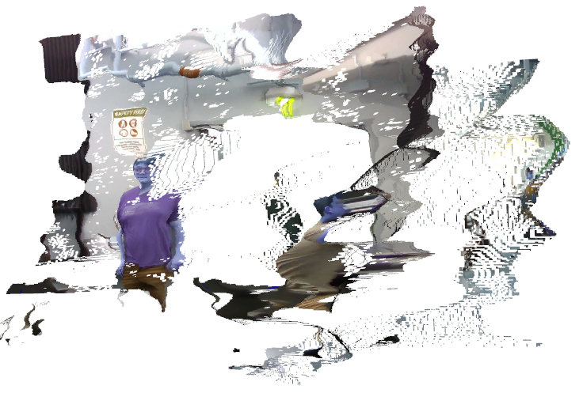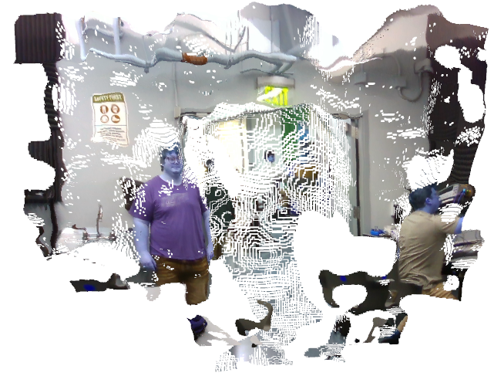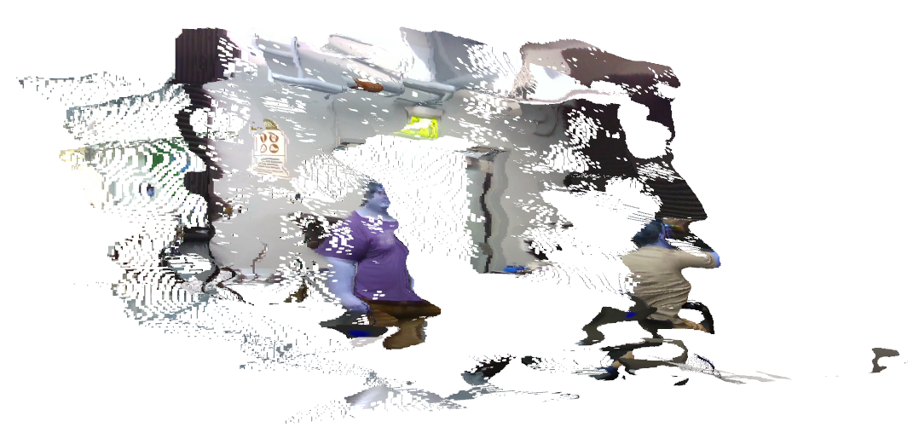

### **Subsystem Validation**

Since this subsystem’s results are all visual in nature I found it a little difficult to devise ways to measure the validation of this system numerically. However, when it comes to the training of the model, checking the convergence of the Generator and Discriminator can be very useful.

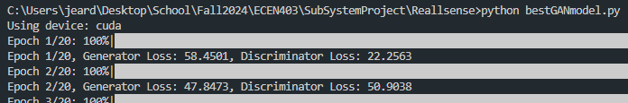

**Figure 3:** Screenshot of Terminal Showing Generator Loss Vs Discriminator Loss

This is the output I have for the training loop for my GAN model, which shows me which device it’s using (“cuda” is selected for my GPU), what the current epoch is its percentage complete of that epoch and the loss for both Generator and Discriminator. The goal is for them to converge at 50% each showing they have balanced eachother out.

Other validation checks in place are checking both the RGB and depth cameras when executing my model. This is what that display looks like.

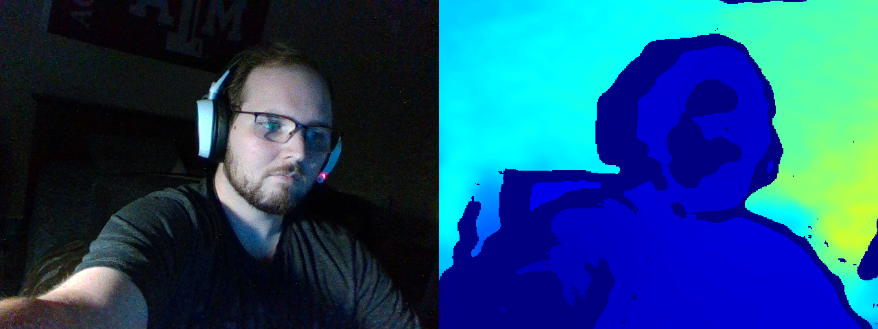

**Figure 4:** Display of Both Cameras When Running

Finally, the last validation test in place is to check and see the trained Generator’s outputs from the raw input image and to compare the two visually.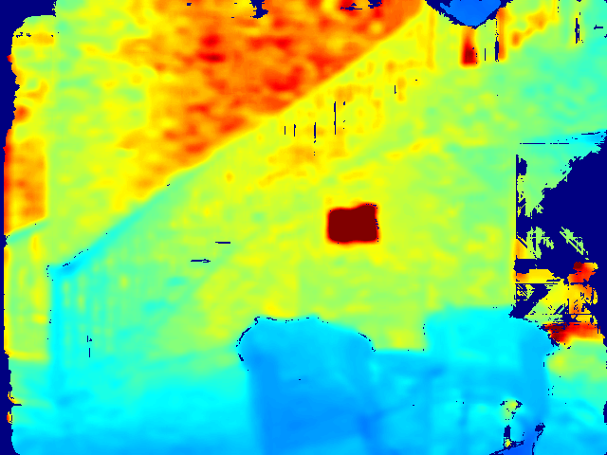

**Figure 5:** Raw Depth Map Input **Figure 6:** Enhanced Depth Map Output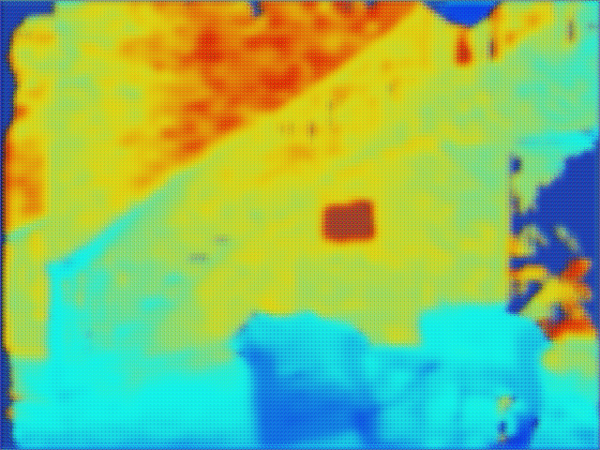

The solid deep blue is missing data. As you can see the enhanced depth map shows significant improvements from the raw input. In several spots you can see where the GAN has filled in these spots and matched the surrounding area.

### **Subsystem Conclusion**

All components of this subsystem operate as intended and to an acceptable standard. However, its current performance falls short of the desired standard. To achieve significant improvement, several key refinements are needed: utilizing a higher-quality depth map dataset (one free from pre-existing missing data like the current dataset), increasing the dataset size substantially (from 700 images to an optimal range of 10,000 to 500,000 for effective model training), and leveraging superior computational resources (as current limitations restrict training to 20 epochs with runtimes of 3–4 hours). With these improvements, the model is expected to perform markedly better. Many of these limitations are slated for resolution or improvement in the next phase of development for ECEN 404.

1. **RGB Sensor Subsystem Report (Rufus Tadpatri 830003175)**
   1. **Subsystem Introduction**

The RGB sensor subsystem is designed to operate in scenarios with high visibility. This subsystem takes in an input image, preprocesses the image using the trained GAN model, and independently generates a 3D point cloud from the image.

A GAN model was developed that converts RGB images to 3D point clouds. RGB data is taken in and preprocessed to optimize input for the GAN. The RGB sensor allows the ability to train the GAN model to convert from RGB to point cloud in order to integrate into the final 3D model.

Currently, there exists a technology that utilizes CNN layers and diffusion-denoising approaches. Convolutional neural networks use several layers to maintain relevant information without causing a storage issue. Our RGB subsystem will use machine learning algorithms to train the model in order to develop a GAN model. This model will be trained to preprocess RGB data; this will help with processing speed as well as the reliability of the model.

* 1. **Subsystem Details**

The GAN model was developed using StackGAN architecture. StackGAN architecture is a two-stage network, meaning it has two generators and two discriminators. The python program was set up for the GAN model to first be trained on a sample dataset pulled from an online repository. This dataset contained 200 images, and the model was trained on each image for 500 epochs. The more data that could be put through the model, and the more epochs per image, would result in a higher developed and accurate model. Due to time constraints- 500 epochs for 200 images took multiple days to train -the model was not further developed. Moving forward, continuing to train the model on more data and for longer periods of time is an option to continue to improve the product. After the model was trained, a second python program, which references the GAN model, was developed to function as the user interface. The program opens the RGB sensor viewer via CL-Eye Test program, takes in the input image, then preprocesses the image and puts it into the trained GAN model. From this, the GAN model is able to generate a 3D point cloud, which opens on the laptop using OpenCV for the user to view.

Further steps to be taken to improve the product includes increased training of the GAN model, both on images and epochs, as well as aligning the sensor with others on the project. For example, concurrent use with the depth sensor alone will allow for a more space-aware 3D point cloud.

In the next stages of the project, for subsystem integration, the GAN model built to support the RGB sensor will work directly with the other three sensors used on the project.

* 1. **Subsystem Validation**

Figure 7 below shows the input image that can be put into the model. Figure 8 and figure 9 show what the 3D point cloud looks like after being put through the subsystem.

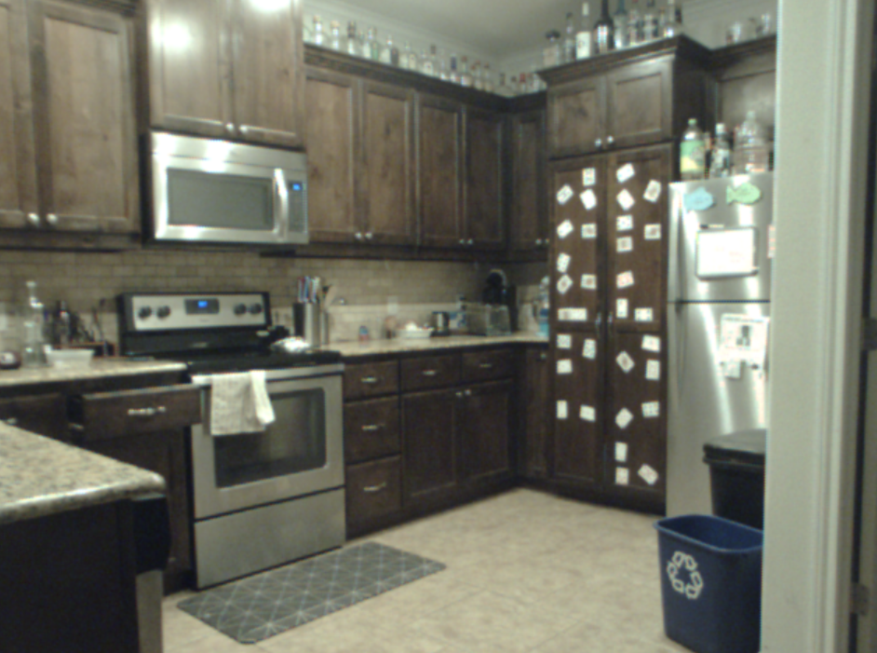

***Figure 7: Input image into RGB Subsystem***

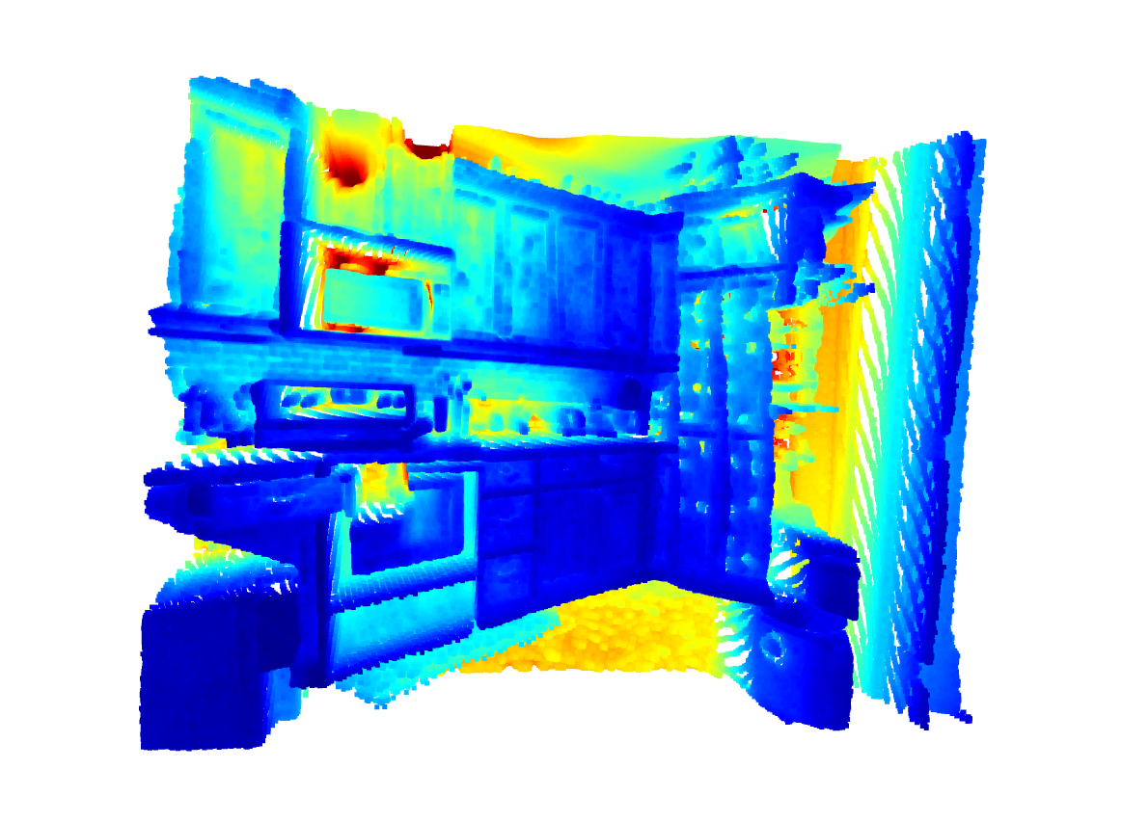

***Figure 8: Output 3D Point Cloud***

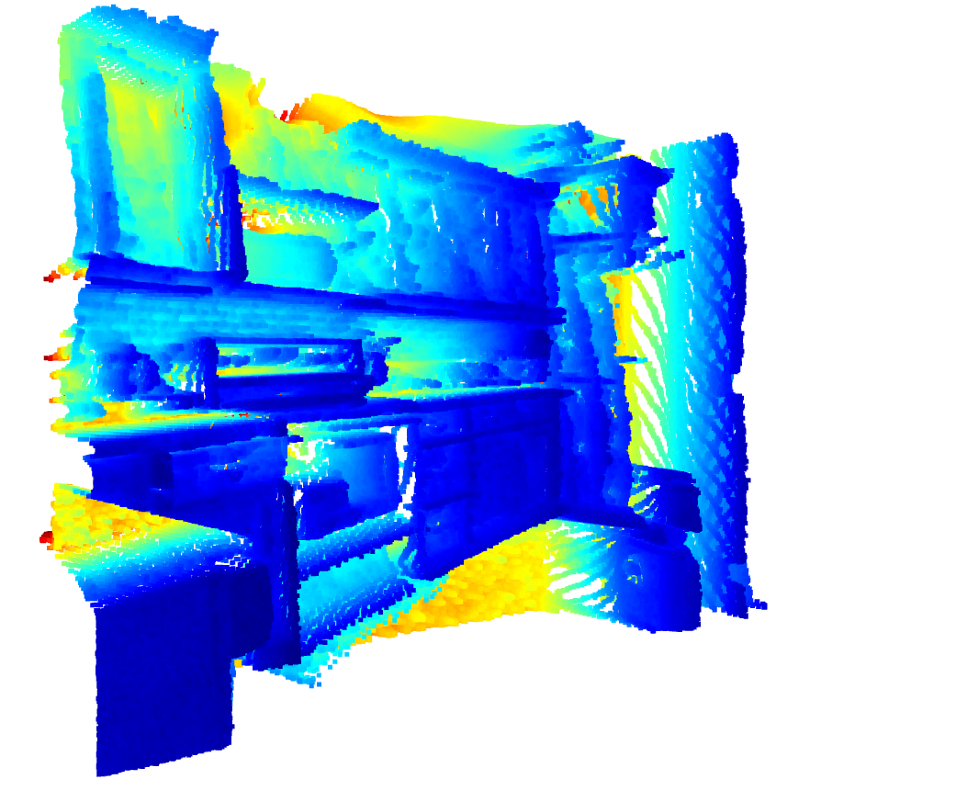

***Figure 9: Output 3D Point Cloud Alternate Angle***

As seen in figures 8 and 9, from taking in an input image, the program will output a 3D rendering that can be rotated and navigated to see multiple angles of the environment.

* 1. **Subsystem Conclusion**

The RGB subsystem functions as intended. It correctly takes in an input image from an RGB sensor and generates a 3D point cloud accurately and in a timely manner. The GAN is also set up for subsystem integration. Moving forward, the RGB subsystem is fully completed per the individual subsystem deliverable and is ready for the next stages of the project.

1. **Thermal Sensor Subsystem Report (Kyle Smejkal 627002694)**
   1. **Subsystem Introduction**

The thermal camera subsystem captures thermal image data to show areas of high heat for the first responders. In order to make a usable point cloud from this data, a depth map is needed. In the final form of this project, the depth data from the Realsense camera or Ultrasonic sensor can be used for that depth map. For this report, the depth data from the Realsense camera was used. The thermal image data and depth data are then used to train two separate GAN models, one for each data type. These GAN models are based on Convolutional Neural Networks and are used to generate images based on the input sensor data, which can be used to make a point cloud.

* 1. **Capturing Thermal Data**

The thermal imaging data is captured using a MLX90640-55 thermal camera connected to a Raspberry PI 3 model B v1.2 via the I2C interface. **Figure 10** shows the pinout of connecting the camera to the Raspberry PI. **Table 3** shows the specifications of the camera.

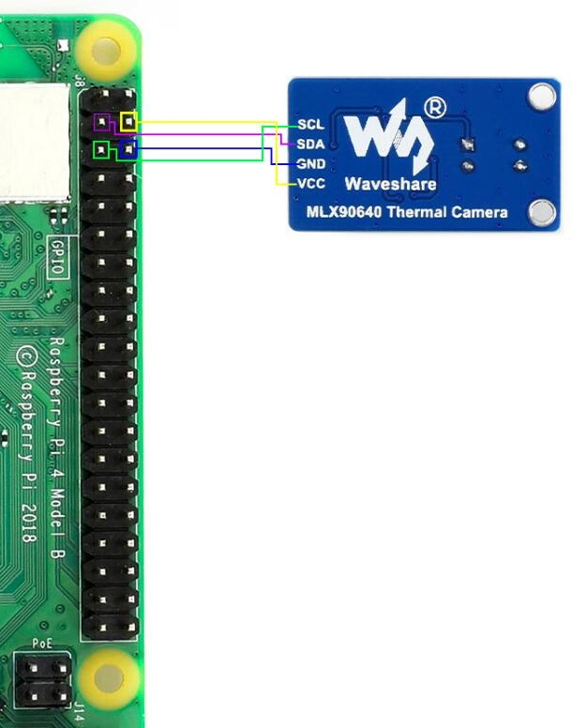

**Figure 10:** Pinout of Thermal Camera connection

| Resolution | 32 x 24 |
| --- | --- |
| FOV | 55° x 35° |
| Target Temperature  (Temperature range of sensor) | -40℃ ~ 300℃ |
| Refresh Rate | 0.5Hz~64Hz (Programmable) |

**Table 3:** MLX90640 Thermal Camera Specifications

The thermal data is captured in a 32x24 array that is then resized to 640x480 to match the size of the depth image from the realsense camera and saved as a ‘.PNG’. The image is then moved over to the host device for training the GAN model.

* 1. **Training the GAN model**

Before training the GAN model the images need to be formatted correctly. This is done by changing the depth and thermal images into 1 color channel 640x480 pixel images. The thermal images are outputted from its sensor as only having 1 channel, so no change is needed. The depth image comes in as an 640x480 RGB image with blue colors being closer to the camera and red meaning it is further away from the camera, so only the blue channel is saved to represent the depth image. Lastly, is the GAN architecture. **Figure 11** shows the architecture for the Discriminator and **Figure 12** shows the architecture for the generator.

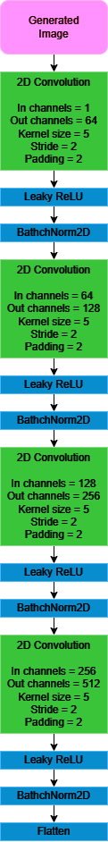 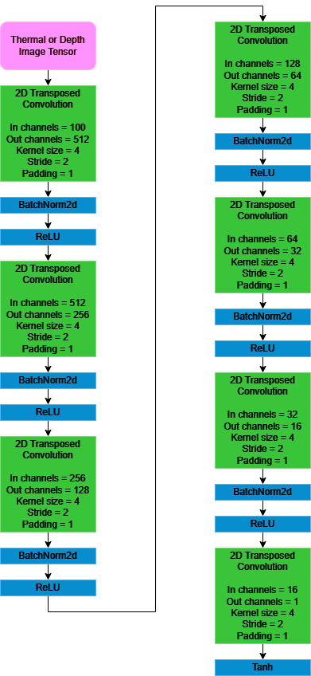

**Figure 11: Discriminator Architecture Figure 12: Generator Architecture**

Now using the above architecture, two separate GAN models are trained. One uses depth images to train and the other uses thermal images. During the training process, the loss function used at all steps is the BCEWithLogitsLoss function from pytorch. This function combines the Sigmoid and BCEloss functions into one. There are three steps each epoch during the training process. First, the discriminator trains on the images provided. (Only one type of image is trained on at a time) Next, the discriminator trains using images generated by the generator. Lastly, the generator is trained using the discriminator as a judge. At the end of each epoch, the loss of the discriminator and generator are outputted to show the progress of the training process.

* 1. **Point Cloud Generation**

The point cloud generation is done by mapping the thermal image into 3d space using the generated depth image to map it along the z-direction. This is done using the camera intrinsics matrix to line up the two images. **Figure 13** is an example of this. The image in **Figure 13** can be thought of as the thermal image and the scene as the depth image.

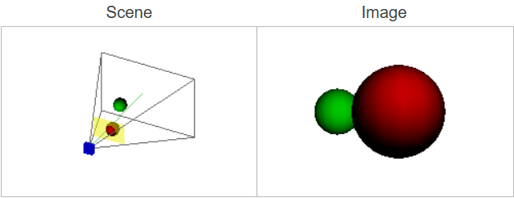

**Figure 13: Camera Intrinsics Example**

The point cloud is generated by going pixel by pixel through the thermal image and assigning it a depth value based on the depth image. **Figure 14** and **Figure 15** show an example of a thermal image and the depth image respectively. Note that the Realsense camera has a wider FOV then the MLX90640, so before the point cloud is calculated, the depth image has to be processed to account for this difference. **Figure 16** and **Figure 17** show what the resulting generated point cloud looks like from two different angles.

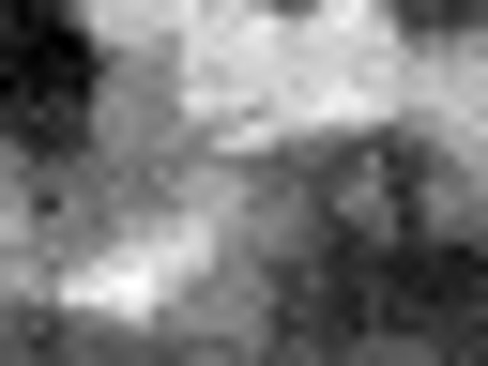 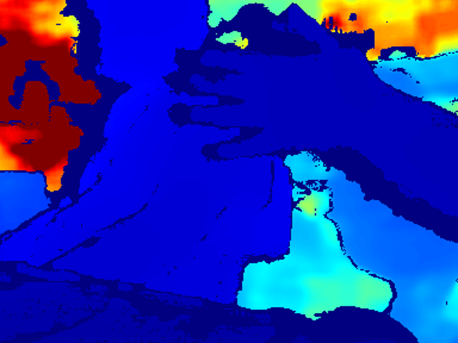

**Figure 14: Thermal Image Example Figure 15:Depth Image example**

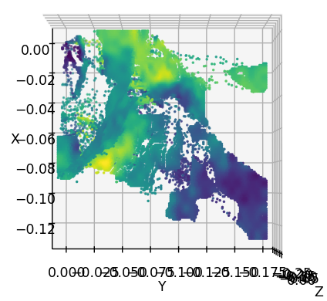 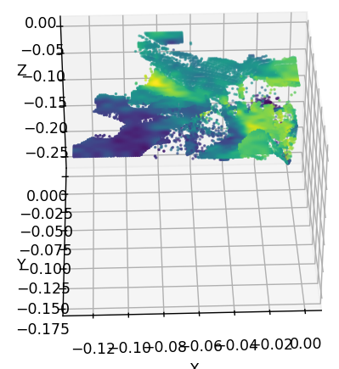

**Figure 16: Point Cloud Example Figure 17: Different angle of Point Cloud**

* 1. **Subsystem Validation and Conclusion**

The thermal camera subsystem works as intended as shown in the previous figures, but is held back by the camera that is currently being used and the amount of training time/data that the model has had. The thermal camera being used is a very low resolution, so when the GAN model trains on the low resolution images, it outputs a very noisy image where the details of the image are not distinguishable at all. This leads to a point cloud that isn’t useful. The model has also only been trained on just over 500 images for about 10 hours in total. To improve this subsystem, a better camera with higher resolution and more training time/data are needed.

1. **Ultrasonic Sensor Subsystem Report**

**(Quinn LeBoeuf, 529007084)**

**5.1. Subsystem Introduction**

The Ultrasonic Sensor Subsystem relies on leveraging sparse and noisy distance measurements captured by the ultrasonic sensor and enhancing this data with a GAN model to produce accurate 3D point clouds. The GAN model for this subsystem is designed to use processed output measurements from the ultrasonic sensor. This processed data involves ultrasonic distance measurements that will then be used to develop a depth map from ultrasonic sensor data. Processed data from here are fed into the GAN model to further create an improved depth map and thus infer an RGB image, which is used to develop a 3D point cloud. This point cloud generated will later be merged together with other sensor data to form one unified view of some scanned environment, while also being used as a backup considering the project is designed for emergency situations, in which other sensors may not properly work depending on environmental hazards.

**5.2. Data Retrieval and Processing**

Data retrieval for this subsystem occurs through the ultrasonic sensor (HC-SR04) and the corresponding microcontroller (Arduino Uno). From this sensor, distance measurements up to 4 meters can be read. Original minimum distance requirements were 10 meters, however this proved to not be possible given budget constraints based on how data will need to be processed. A 60 millisecond delay between measurements was decided for maximum accuracy without causing overlapping measurement issues during sensor movement and rotation. Ultrasonic sensor measurements will still need conversion to depth map data to provide an image for GAN model training, as well as input data. This conversion will occur by using multiple ultrasonic sensors which will use phased array analysis to create a noisy depth map of some environment. Temporary online datasets have been used to test and train the GAN model for operation based on predicted ultrasonic sensor scans. More discussion of this topic is provided in the subsystem validation.

**5.3. GAN Model Structure and Training**

The GAN model used in this system is designed to enhance depth maps and generate inferred RGB images, ultimately enabling the creation of 3D point clouds. The architecture consists of two key components: the Generators (U-Net style) and Discriminators (PatchGAN style), trained using a combination of adversarial and cycle consistency losses. Training begins by first preprocessing the paired depth and RGB images from the dataset through resizing and normalization transformations. The model has two generators: one generates RGB images from depth maps, and the other cleans the noisy depth maps. Generators are trained on L1 losses between generated outputs and their respective targets, while Discriminators classify between real and fake images using adversarial losses. These two objectives ensure that the generators produce realistic and accurate outputs. At each epoch, the model performs an alternative update of generator and discriminator parameters by using the Adam optimizer. The cycle consistency losses ensure that the depth to RGB and vice-versa transformations preserve the content structure of the input, while the adversarial losses direct the generators in producing visually compelling output.

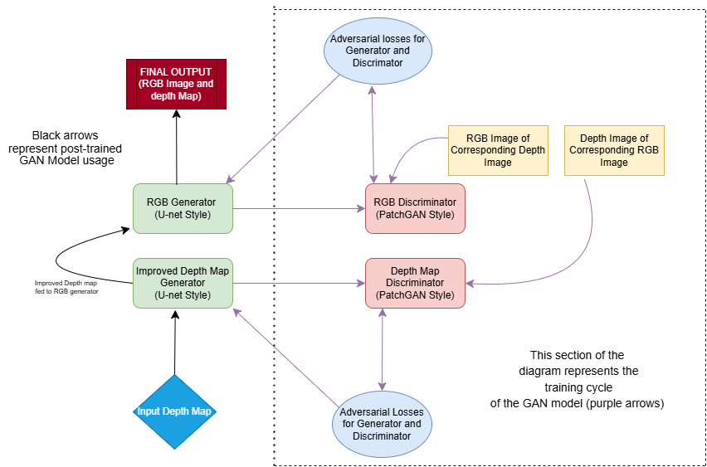

Figure 18: GAN model training and usage implementation

The model was trained for 50 epochs while logging Generator and Discriminator losses at regular intervals. This training ensures the GAN model is capable of properly enhancing depth maps from the ultrasonic sensor as well as generating an RGB image, which is needed for creating a point cloud image. Figure 18 shows the input/output architecture of the model, and highlights the training architecture for proper image generation

**5.4. Subsystem Validation**

**5.4.1. Data Retrieval Validation**

The ultrasonic sensor data collection was validated by comparing the measured distances against known reference values, demonstrating consistent accuracy within an acceptable error margin. This confirms that the sensor is functioning properly and providing reliable input for further processing by the GAN model. While the sensor data collection validation has been executed, it is still not processed properly for the GAN model to use. This is a problem that was realized halfway through the project, however focus has been on the machine learning model and its performance. A 3D ultrasonic scanner design has been conceptualized as the solution to this issue, but requires many outside implementations (PCB design, Phased array analysis, etc.) that will have to be worked on before, as well as going into, ECEN 404.

**5.4.2. GAN Model Training Validation**

During Training, the model outputted the losses of both the generators and discriminators during each epoch. Generator losses decrease while maintaining a moderate value indicating the improvement of the generator during training. The discriminator loss values also decrease towards more balanced levels. Both these occurrences prove the model is learning properly and the data is not converging (or being overtrained). Figure 19 shows an image of a training test to make sure the loss functions were working correctly.

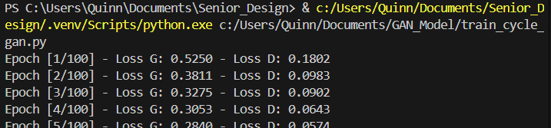

Figure 19: Generator and Discriminator Losses During Training Test

**5.4.3. GAN Model Operation Validation**

The operation of the GAN Model was validated using visual output results. In figure 20, we can see multiple scenarios where the model takes in depth image data (the depth image data is based on the ground truth RGB image), improves the depth image, generates an RGB image from said depth image, and then a corresponding point cloud is generated. Possible improvements for environmental generation accuracy include merging point clouds from multiple angles to build a complete environment (notice the point cloud cannot understand there is empty space behind the table unless another image is taken from a separate angle). More training with a larger dataset could prove to be useful given more time and improved GPU performance.

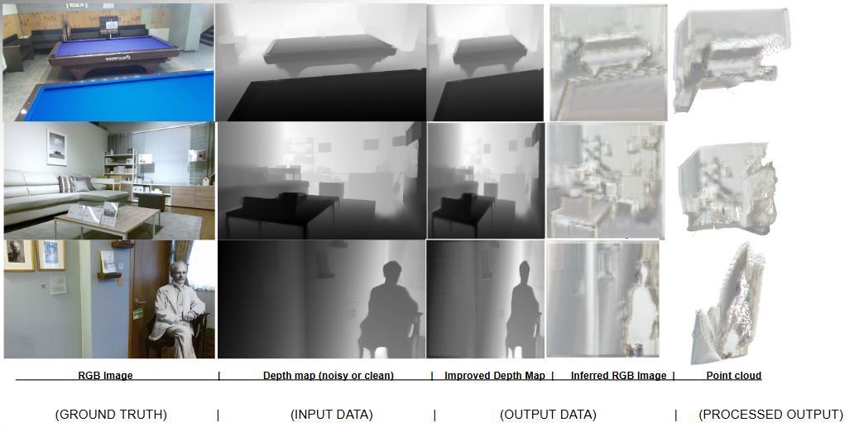

Figure 20: Trained GAN Model Input and Output Results

**5.5. Subsystem Conclusion**

The Ultrasonic Sensor Subsystem uses machine learning (GAN model) to reconstruct sparse/noisy ultrasonic depth data into high-resolution 3D reconstructions. By using a U-Net-based generator for depth map enhancement and RGB inference, along with a PatchGAN discriminator for realistic output validation, the system ensures accurate and visually coherent results. The integration of adversarial and cycle consistency losses further refines the model performance, which enables the detailed creation of 3D point clouds. This subsystem will play a key role in backup environment reconstruction, in which this sensor can collect and process data where others cannot, enabling critical applications of environmental reconstruction for first responder operations.